SCENARIO-BASED
QUESTIONS AND ANSWERS
Cloud Computing and Big Data Analytics

Course Code: CSA1515
Course Outcome: CO2 – Analyze virtualization architectures to identify performance and security issues in cloud computing environments

Name: M. Akhil kumar
Reg no: 192572060

Question 1: Cloud Architecture for a Video Streaming Platform

Scenario
The media company must serve millions of concurrent viewers while keeping buffering low and controlling the cost of a highly variable workload.
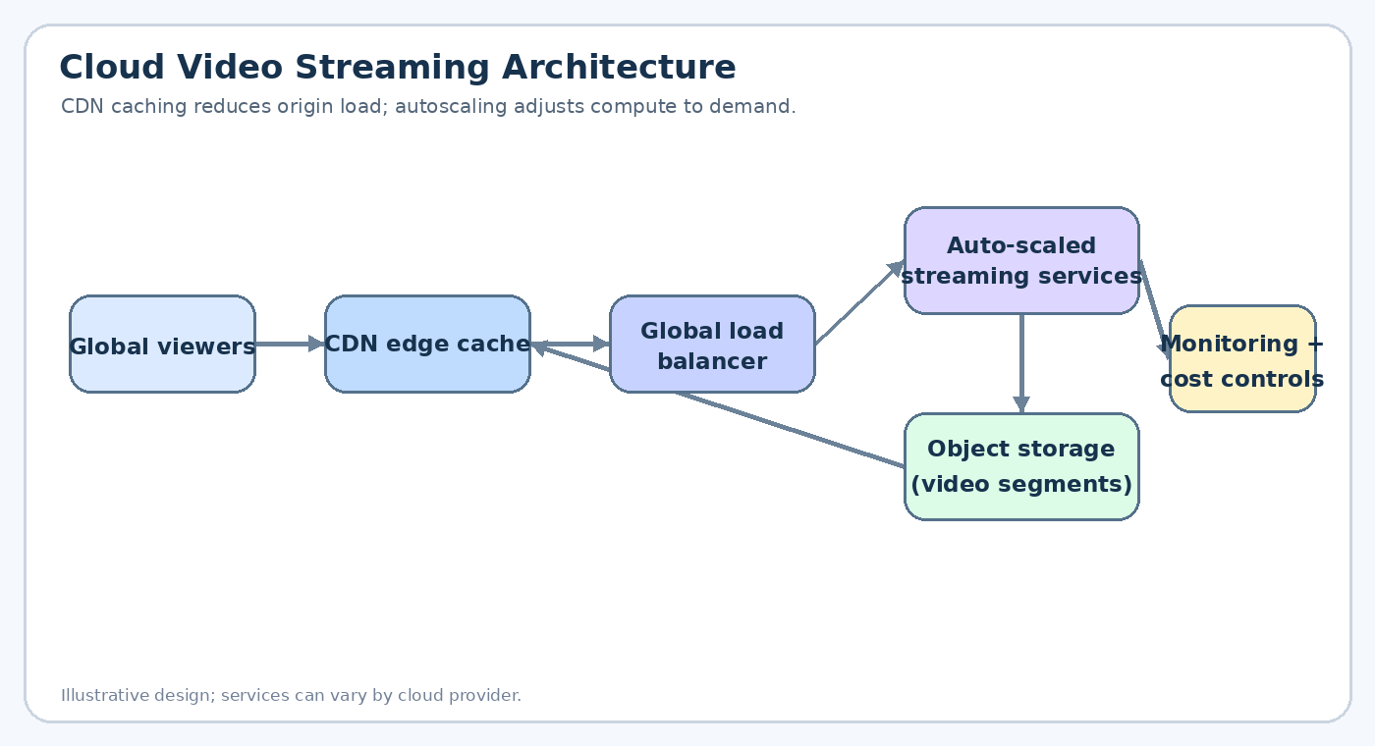

1.1 Proposed Architecture
- Content delivery network (CDN): Cache popular video segments at edge locations close to viewers. This reduces latency and the number of requests reaching the origin.
- Object storage: Store master videos and transcoded streaming segments in durable object storage. Use adaptive-bitrate formats so the player can switch quality according to network conditions.
- Load balancing: Use a global traffic manager and regional load balancers to distribute requests across healthy application instances and regions.
- Auto-scaling compute: Run stateless APIs, authentication, catalogue, and session services on a managed compute platform. Scale out when request rate, CPU, memory, or queue depth increases.
- Streaming workflow: Upload videos, transcode them into multiple resolutions, package segments, and publish them to the CDN. Keep frequently used metadata in a managed cache.

1.2 How Load Balancing and Auto-Scaling Help
- Load balancing: Health checks remove unhealthy instances from rotation and distribute traffic across healthy instances. Global routing can direct users to a nearby region.
- Auto-scaling: Scale-out adds instances during a major release or live event; scale-in removes unneeded capacity after demand falls. Configure minimum capacity and warm-up periods to avoid slow reactions.
- Performance protection: Use queues and rate limits for non-critical tasks, and isolate the video delivery path from account, payment, and analytics services.

1.3 Cost Optimization Strategies
- Cache aggressively: Increase CDN cache-hit ratio and set suitable cache-control policies for immutable video segments.
- Right-size resources: Choose instance sizes based on measured utilization and use autoscaling rather than keeping peak capacity running all day.
- Use storage tiers: Move rarely accessed source files to lower-cost storage tiers while retaining frequently streamed segments in suitable tiers.
- Observe cost by workload: Apply tags, budgets, alerts, and per-service dashboards. Review data-transfer charges and remove unused resources.

1.4 Risks and Validation
- Potential risks: Cache misses during a launch, regional outages, bandwidth bottlenecks, and unexpectedly high egress costs can affect service quality.
- Testing: Run load tests for expected peak concurrency, simulate instance failures, and measure startup delay, rebuffering ratio, CDN cache-hit rate, and cost per viewing hour.
- Conclusion: A CDN-first design, backed by elastic application services, resilient storage, and continuous cost monitoring, supports large-scale streaming with lower latency and controlled spending.

Question 2: Container Orchestration Across Multiple Cloud Providers

Scenario
The fintech startup needs consistent container deployments across multiple cloud providers, along with reliable service discovery and efficient scaling.
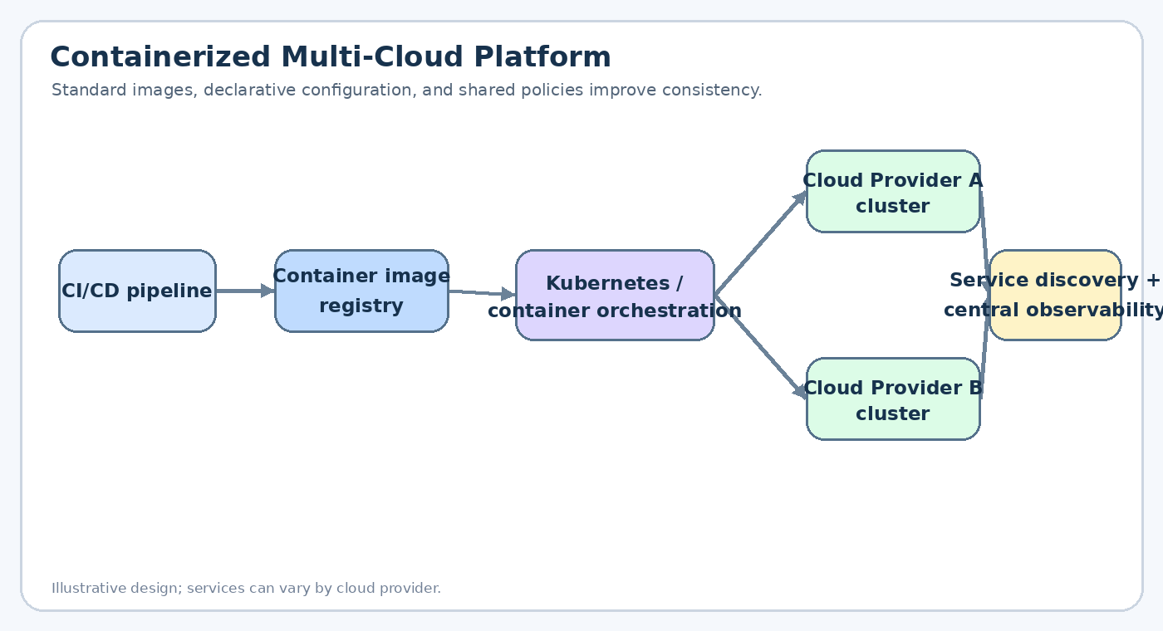

2.1 Proposed Multi-Cloud Solution
- Container images: Package each service and its dependencies into versioned container images. Store approved images in a secured registry and scan them for vulnerabilities.
- Orchestration: Use Kubernetes or a comparable managed container orchestrator in each cloud. Define workloads, services, secrets, resource limits, and deployment policies declaratively.
- CI/CD pipeline: Build and test once, then promote the same signed image and configuration through development, staging, and production environments.
- Infrastructure as code: Use reusable templates to provision networks, clusters, access policies, and monitoring consistently across providers.
- Placement strategy: Place workloads in both clouds where there is a clear availability, regulatory, or resilience benefit. Avoid unnecessary duplication of every component.

2.2 Service Discovery and Scaling
- Service discovery: Use cluster service names and internal DNS for services within a cluster. For cross-cloud discovery, use a controlled service registry or global traffic layer with health checks.
- Horizontal scaling: Scale replicas using CPU, memory, request rate, or queue depth. Configure resource requests and limits so the scheduler can place workloads predictably.
- Traffic management: Use ingress controllers or gateways with TLS, authentication, rate limits, and routing rules. Keep service-to-service communication private where possible.
- Observability: Collect logs, metrics, traces, deployment events, and audit records in a shared monitoring platform with consistent service identifiers.

2.3 Benefits and Risks of Multi-Cloud
- Benefits: Reduces dependence on one provider, can improve geographic reach, supports provider-specific capabilities, and may help meet resilience or procurement requirements.
- Risks: Different identity systems, networking models, managed services, egress fees, and operational tooling can increase complexity.
- Security controls: Use least-privilege identities, centralized policy standards, image signing, secrets management, network segmentation, and regular vulnerability scanning.
- Conclusion: A shared container and CI/CD standard with provider-specific infrastructure modules provides consistency while preserving the ability to operate across clouds.

Question 3: Backup and Disaster Recovery for an E-Learning Platform

Scenario
The e-learning platform has lost data after accidental deletion and needs dependable backups, replication, versioning, and a tested continuity plan.
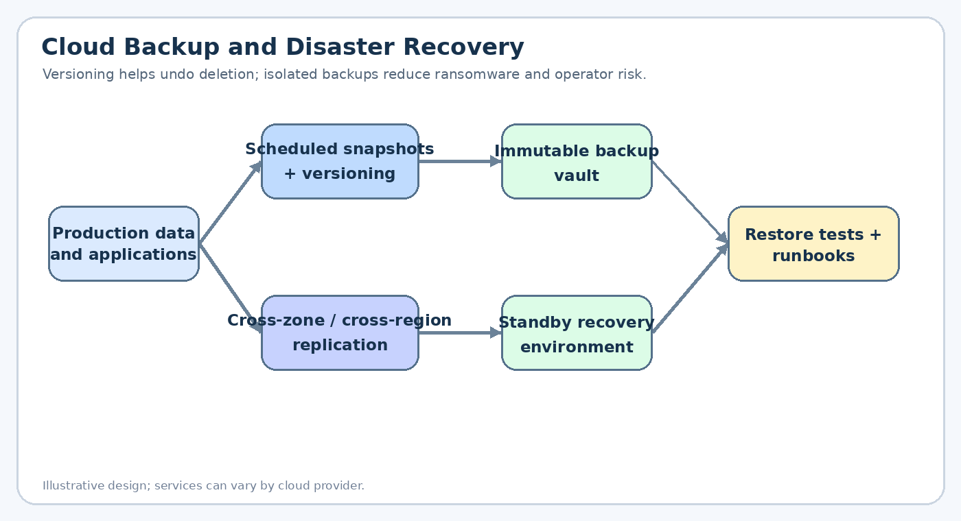

3.1 Backup and Recovery Architecture
- Versioning: Enable object or database versioning so earlier versions can be recovered after accidental overwrites or deletion.
- Scheduled backups: Create automated, policy-based backups of databases, object storage, configuration, and critical application state. Set retention periods according to business and compliance needs.
- Replication: Replicate critical data to a separate availability zone or region. Replication improves availability but should not be treated as the only backup because deletions or corruption may also replicate.
- Immutable backup vault: Keep protected backup copies in a separate account or security boundary with restricted deletion permissions and, where supported, immutability controls.
- Recovery environment: Maintain infrastructure templates and documented steps to rebuild application services in a recovery region.

3.2 RTO and RPO
- Recovery Time Objective (RTO): The maximum acceptable time to restore the service after disruption. Reduce RTO with automated infrastructure deployment, ready-to-use recovery capacity, documented runbooks, and regular failover drills.
- Recovery Point Objective (RPO): The maximum acceptable amount of data loss measured in time. Reduce RPO through frequent backups, transaction-log backups, and suitable replication frequency.
- Business targets: Agree RTO and RPO with business owners for each service. Critical enrolment and assessment data may need tighter targets than archived course media.
- Recovery verification: Restore backups into an isolated test environment and validate record counts, application integrity, access controls, and user workflows.

3.3 Business Continuity Steps
- 1. Detect and assess: Alert on deletion, corruption, service failure, and backup-job errors. Identify affected datasets and the last known good recovery point.
- 2. Contain: Restrict compromised credentials or automation and prevent further destructive changes.
- 3. Restore: Select a clean backup or version, restore data in dependency order, and redirect application services to the recovered data.
- 4. Validate and communicate: Test login, course access, enrolment, and assessment submission. Inform stakeholders about service status and any known data gap.
- 5. Learn: Document the incident, improve permissions and retention policies, and test the updated recovery procedure.
- Conclusion: Versioned and isolated backups, appropriately frequent replication, and routine restore drills help recover from accidental deletion while meeting agreed RTO and RPO targets.

Question 4: Secure Hybrid Cloud for a Government Agency

Scenario
The agency wants to use cloud services for non-sensitive workloads while retaining applications and data that must remain on-premises for compliance reasons.
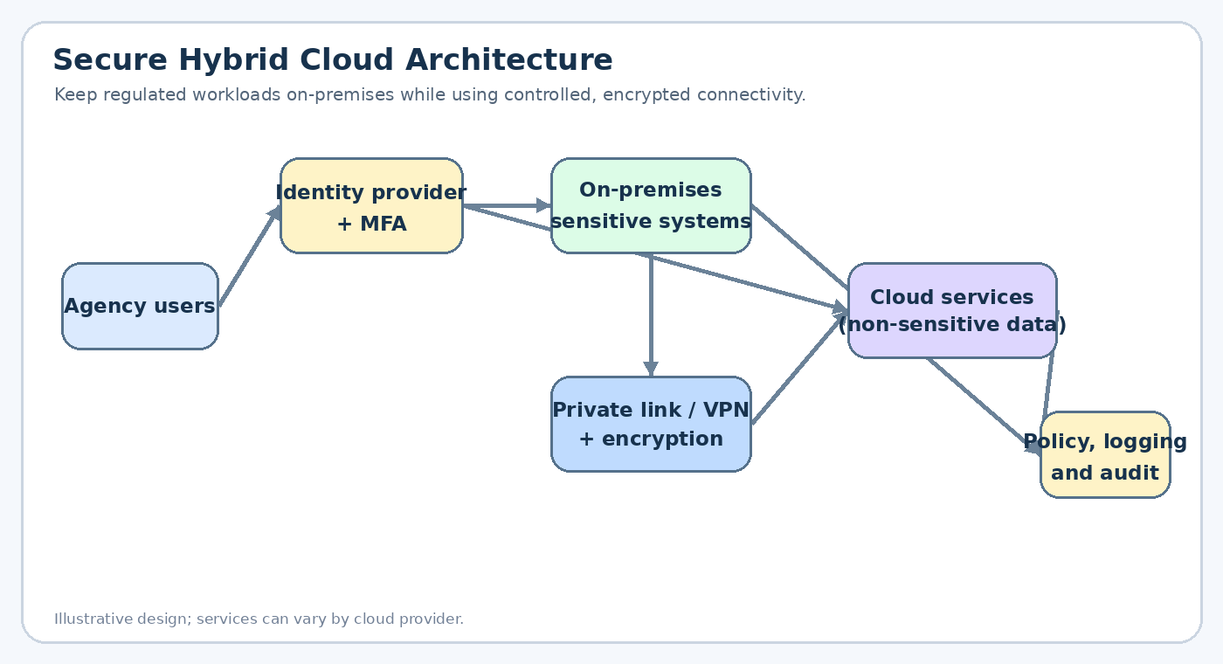

4.1 Proposed Hybrid Architecture
- Workload separation: Keep regulated systems and sensitive datasets on-premises when required by policy. Place approved public-facing or non-sensitive applications in the cloud.
- Secure connectivity: Connect environments using a private dedicated link where available, or a site-to-site VPN. Encrypt traffic in transit and restrict routes to approved services.
- Network segmentation: Separate networks by sensitivity and function. Use firewalls, security groups, private endpoints, and explicit allow-list rules instead of broad connectivity.
- Controlled integration: Expose only necessary APIs through an authenticated gateway. Avoid copying sensitive records into cloud services unless policy and data classification permit it.

4.2 Identity Management and Encryption
- Central identity: Integrate with the agency identity provider where feasible. Apply role-based access control, least privilege, multifactor authentication, and periodic access reviews.
- Workload identities: Use managed identities or short-lived credentials for applications instead of hard-coded keys. Store secrets in an approved secrets manager and rotate them.
- Encryption at rest: Encrypt databases, disks, object storage, and backups. Manage keys through controlled key-management services, with separation of duties for sensitive keys.
- Encryption in transit: Use TLS for APIs and service communication. Use VPN or private connectivity with encryption as required by the agency's threat model and regulations.
- Auditability: Centralize identity, network, administrative, and data-access logs. Protect logs from alteration and retain them according to policy.

4.3 Hybrid Cloud Management Challenges
- Operational complexity: Different tools and ownership boundaries can make patching, monitoring, capacity planning, and incident response harder.
- Latency and dependencies: Applications that frequently call between on-premises and cloud systems may suffer latency or become unavailable when the connection fails.
- Compliance drift: Misconfigured permissions, data movement, or inconsistent policies can create compliance gaps; use policy-as-code and regular audits.
- Continuity planning: Document what each application does if the private link fails, and test identity, DNS, certificate, and backup dependencies.
- Conclusion: A segmented hybrid design with strong identity controls, encrypted connectivity, centralized audit logs, and clear data-placement rules can balance cloud flexibility with compliance.

Question 5: Multi-Region High Availability and Fault Tolerance

Scenario
The SaaS provider must continue operating if one cloud region becomes unavailable and needs data replication, automated failover, and proactive monitoring.
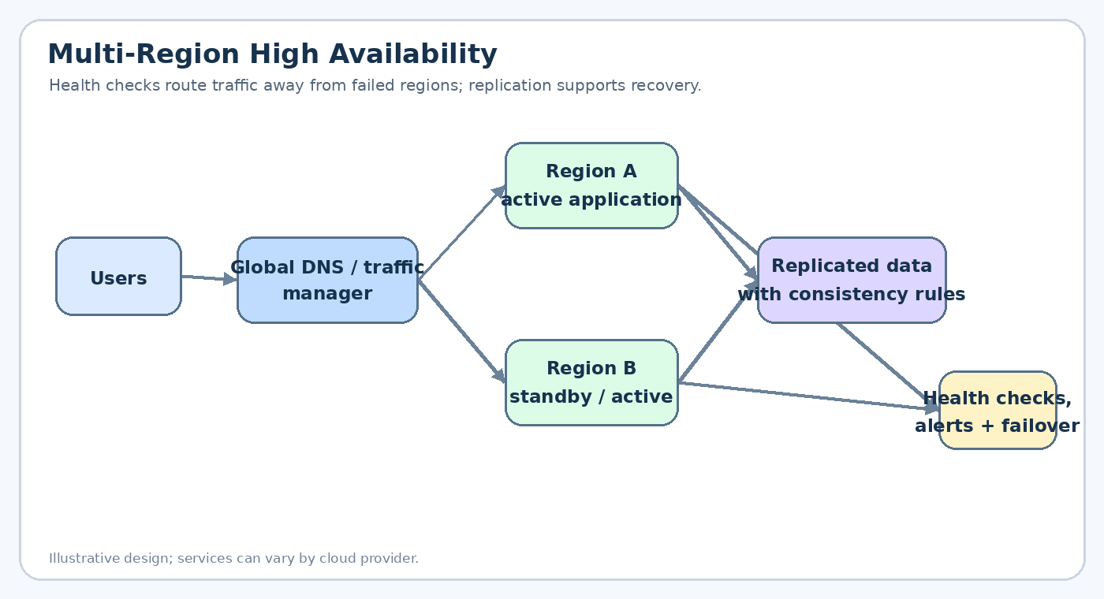

5.1 Multi-Region Deployment Strategy
- Regional deployment: Deploy the application stack in at least two regions. Depending on cost and recovery needs, use active-active or active-passive operation.
- Traffic management: Use global DNS or a traffic manager with health checks to route new requests to healthy regions. Configure suitable health-check intervals and failover thresholds.
- Stateless services: Keep application instances stateless where possible so they can be replaced or scaled in either region without losing session state.
- Dependencies: Replicate configuration, secrets, container images, certificates, and infrastructure definitions so the recovery region can operate independently.

5.2 Data Replication and Failover
- Replication choice: Select synchronous replication when low data loss is essential and latency allows it; select asynchronous replication when distance and performance make synchronous replication impractical.
- Consistency and conflicts: For active-active writes, define conflict resolution and consistency rules. For active-passive systems, define which region is authoritative and how promotion occurs.
- Failover procedure: Detect regional health failure, stop routing traffic to the unhealthy region, promote or connect to healthy data services, and verify critical transactions before declaring recovery.
- Failback: After the failed region is repaired, synchronize data, validate health, and move traffic back gradually rather than immediately switching all users.

5.3 Monitoring and Alerting
- Service indicators: Track availability, latency percentiles, error rates, saturation, database replication lag, queue depth, and successful transaction rates.
- Synthetic checks: Run probes from multiple locations and test key user journeys such as sign-in, checkout, or saving a record.
- Actionable alerts: Set thresholds and alert routing for on-call staff. Avoid alert fatigue by grouping related events and documenting response runbooks.
- Regular exercises: Run controlled failover drills and measure actual recovery time and data loss against the agreed objectives.
- Conclusion: A tested multi-region architecture, correct replication strategy, health-based routing, and actionable monitoring provide resilience against regional failures.

